E-Book Store
Version 1.0 (2016-2017)

Computer Science Project

Developed By
Himanshu Gupta ________________ (Board roll no. )

DARBARI LAL DAV MODEL SCHOOL
SHALIMAR BAGH, DELHI

Index

S no | Description | Page no
1 | Certificate | 1
2 | Introduction | 2
3 | Source Code | 3
4 | Output Screen | 33
5 | Acknowledgement & References | 44
6 | Merits & Limitations | 45

Certificate

This is to certify that “e-book store” computer project is developed by Himanshu Gupta under my supervision in the computer lab of Darbari Lal DAV Model School, Shalimar Bagh in the session 2016-2017.

Mrs. Shalini Arora

Computer Science Teacher
Date: ___________

Introduction

Aim of this project is to make purchasing of books online. It automates the traditional purchasing of books. In traditional purchasing of books, it is difficult to keep record of available books for sale and purchase with the customer. This project makes purchasing of books online by reserving books for customer online which automatically keeps track of available books for each book. There are basically two types of users that can be created:

- ADMINISTRATOR: - This user has access to add a new book, view and update an existing book and view an existing customer’s order status. This also can add book detail, update the record and also handle order of customer online.

- USER (CUSTOMER):- This user has limited access to the system. This type of user mainly includes users who can perform all operations except the admin’s specific operations. Customers’ most commonly performed action is to buy a book. Along with this user can view and update his details.

Whenever any user logs into the system, it identifies the role of the user. Based on the role, home page is displayed to the user which contains all the links for the action that the user has access to.

Source C++ Code

/*
Program name : <e-book store>
Version : <1.0 (2016-2017)>
Last Updated on : <15 December 2016>
Filename : <BOOKPROJ.CPP>
Developers : <Himanshu>
School Name : DLDAV MODEL SCHOOL, SHALIMAR BAGH, DELHI
*/

HEADER FILE INCLUDED <FUNC.H>

fstream f1,f2,f3;
int retkey(int x,int y,int r,int height);
int t,qty,p=-1;
long int sum,sum1;
void load();
char user1[20];

//------------------------------------------------CLASS FOR HISTORY (records) ------------------------------------------
class history
{
char uname[50],bname[70];
int copy,price;
public:
void copyname(char* t);
void copyqty(int t);
void copybook(char* t);
void copyprice(int t);
void showinfo(int t);
void showinfo1(int i);
int chkuname(char* t);
} h;

int history::chkuname(char* t) //matching username
{
int c;
c=strcmpi(uname,t);
return c;
}

void history::showinfo1(int i) //display information
{
gotoxy(4,7+i);
cout<<i+1;
gotoxy(16,7+i);
cout<<bname;
gotoxy(55,7+i);
cout<<copy;
gotoxy(66,7+i);
cout<<price;
sum1+=price*copy;
}

void history::showinfo(int i) //display information
{
gotoxy(4,7+i);
cout<<uname;
gotoxy(16,7+i);
cout<<bname;
gotoxy(55,7+i);
cout<<copy;
gotoxy(66,7+i);
cout<<price;
sum1+=price*copy;
}

void history::copyprice(int t)
{
price=t;
}

void history::copyname(char* t)
{
strcpy(uname,t);
}

void history::copyqty(int t)
{
copy=t;
}

void history::copybook(char* t)
{
strcpy(bname,t);
}

//-----------------------------------CLASS FOR BOOK-----------------------------------------

class book
{
int id,price,year,copies;
char fname[20],sname[20],title[20],pub[30],description[50],genre[10];
public:
void input();
void output();
char* ret_title();
int matchgenre(char* n);
int matchtitle(char* n1);
int matchauthor(char*n,char* m);
int matchpublication(char* n2);
void rettitle();
void showhistory();
void copydec();
int retprice();
int retcopies();
} s;

int book::retcopies()
{
return copies;
}

int book::retprice()
{
return price;
}

void book::showhistory()
{
gotoxy(13,8);
cout<<title;
gotoxy(54,8);
cout<<price;
gotoxy(67,8);
cout<<qty;
sum=qty*price;
}

void book::rettitle()
{
cout<<title;
}

char* book::ret_title()
{
return title;
}

int book::matchpublication(char* n)
{
int c;
c=strcmpi(n,pub);
return c;
}

void book::copydec()
{
copies-=qty;
}

int book::matchauthor(char*n,char* m)
{
int c,k;
c=strcmpi(n,fname);
k=strcmpi(m,sname);
if(c==0&&k==0)
return 0;
else
return 1;
}

int book::matchgenre(char* n)
{
int c;
c=strcmpi(n,genre);
return c;
}

int book::matchtitle(char* n1)
{
int c;
c=strcmpi(n1,title);
return c;
}

void book::input() //input
{
cout<<"enter title : ";
gets(title);
cout<<"enter book id : ";
cin>>id;
cout<<"enter auther's first name : ";
gets(fname);
cout<<"enter author's last name : ";
gets(sname);
cout<<"enter the publication : ";
gets(pub);
cout<<"enter genre : ";
gets(genre);
cout<<"enter price : ";
cin>>price;
cout<<"enter publishing year : ";
cin>>year;
cout<<"enter number of copies : ";
cin>>copies;
cout<<"book's desription : ";
gets(description);
f1.open("books.dat",ios::binary|ios::out|ios::app);
f1.write((char*)&s,sizeof(s));
f1.close();
}

void book::output() //output
{
cout<<"title : "<<title<<endl
<<"book id : "<<id<<endl
<<"author's name : "<<fname<<" "<<sname<<endl
<<"genre : "<<genre<<endl
<<"price : "<<price<<endl
<<"publication : "<<pub<<endl
<<"publishing year : "<<year<<endl
<<"number of copies : "<<copies<<endl
<<"book's desription : "<<description<<endl;
}

//-----------------------------CLASS FOR USERS------------------------------------------------
class user
{
char f_name[20],l_name[20],password[20],usernm[20],mob[11];
public:
void create_acc();
void show_acc();
int matchuser(char* n);
void retusername();
char* retpass();
void change(int c);
} u;

void user::retusername()
{
cout<<f_name<<" "<<l_name;
}

char* user::retpass()
{
return password;
}

int user::matchuser(char* n)
{
int c;
c=strcmpi(n,usernm);
return c;
}

void user::create_acc()
{
cout<<"\t\t\tCREATING ACCOUNT\n";
cout<<"\n\t1. First name :\t ";
gets(f_name);
cout<<"\n\t2. Last name :\t ";
gets(l_name);
cout<<"\n\t3. Mobile :\t ";
cin>>mob;
cout<<"\n\t4. Username :\t ";
gets(usernm);
cout<<"\n\t5. Set Password :\t ";
gets(password);
}

void user::show_acc()
{
cout<<"\n\n~~~~~~~~~~~~~~~~~~~~~~~~~~~~~~~~~~~~~~~~~~~~~~~~~~~~~~~~~~~~~~~~~~~~~~~~~~~~~~"<<endl
<<"\t\t\t\tACCOUNT"<<endl
<<"~~~~~~~~~~~~~~~~~~~~~~~~~~~~~~~~~~~~~~~~~~~~~~~~~~~~~~~~~~~~~~~~~~~~~~~~~~~~~~"
<< endl<<endl
<<"\t1. First name\t:\t "<<f_name<<endl<<endl
<<"\t2. Last name \t:\t "<<l_name<<endl<<endl
<<"\t3. Mobile \t:\t "<<mob<<endl<<endl
<<"\t4. Username \t:\t "<<usernm<<endl<<endl
<<"\t5. Password \t:\t "<<password;
}

void user::change(int c)
{
clrscr();
cout<<"\n\n\n\n";
switch(c)
{
case 1: cout<<"\t\tfirst name : "<<f_name<<endl
<<"\t\tre-enter first name : ";
gets(f_name);
break;
case 2: cout<<"\t\tlast name : "<<l_name<<endl
<<"\t\tre-enter last name : ";
gets(l_name);
break;
case 3: cout<<"\t\tmobile no. : "<<mob<<endl
<<"\t\tre-enter mobile no. : ";
gets(mob);
break;
case 4: cout<<"\t\tusername : "<<usernm<<endl
<<"\t\tre-enter username : ";
gets(usernm);
break;
case 5: cout<<"\t\tpassword : "<<password<<endl
<<"\t\tre-enter password : ";
gets(password);
break;
}
}

//------------------------------------CLASS ENDS-------------------------------------------------------

//-------------------------------------FUNCTIONS START HERE-------------------------------------

void enquiry() //terms and conditions
{
clrscr();
cout<<"\n\t\t\tTERMS AND CODITIONS"<<endl<<endl
<<"1. We will send products to the customer as soon as practicable after it"<<endl
<<" receives payment."<<endl<<endl
<<"2. If the product is defective, customer has to give the details and return it"<<endl
<<" within 2 days of purchase. your product will:-"<<endl
<<"\teither be replaced "<<endl
<<"\tor money will be refuded"<<endl<<endl
<<"3. The customer agrees that the content which the customer accesses, views or "<<endl
<<" downloads and the software used to create it remains the intellectual"<<endl
<<" property of us"<<endl<<endl
<<"4. The customer's personal details will not be sold or leased to any third party"<<endl
<<"\n\n\t\tPRESS ANY KEY TO GO BACK "<<endl;
getch();
}

int password(char* c) //for checking password
{
char ch[20]=" ";
int i=0;
cout<<"enter password : ";
while(1)
{
ch[i]=getch();
if(ch[i]!=8&&ch[i]!=13)
{
cout<<"*";
i++;
}
if(ch[i]==13)
{
ch[i]='\0';
break;
}
else if(ch[i]==8)
{
cout<<"\b";
clreol();
ch[i]='~';
i--;
}
}
if(strcmp(ch,c)==0)
return 0;
else
return 1;
}

int chkaccess() //for entering as guest/admin
{
int c;
while(1)
{
clrscr();
cout<<"\n\t\t~~~~~~~~~~~~~~~~~~~~~~~~~~~~~~~~~~~~~~~~~~~~~~~~~~"<<endl
<<"\n\t\t\t\tWELCOME\n"
<<"\t\t~~~~~~~~~~~~~~~~~~~~~~~~~~~~~~~~~~~~~~~~~~~~~~~~~~";
delay(200);
cout<<"\n\n\n\n\n\t\t\t\tenter as guest "
<<"\n\n\t\t\t\tenter as administrator "
<<"\n\n\t\t\t\texit program";
c=retkey(31,10,3,9);
switch(c)
{
case 1: c=1;
return c;
case 3: int q,n=1;
char nm[20];
clrscr();
gotoxy(20,10);
cout<<"enter username : ";
gets(nm);
if(strcmpi("admin",nm)==0)
n=0;
gotoxy(20,12);
q=password("password");
if(q==0&&n==0)
{
c=2;
clrscr();
cout<<"\n\n\n\t\t\tWELCOME ADMIN";
delay(700);
return c;
}
else
{
cout<<"\ninvalid credentials";
getch();
}
break;
case 5: exit(0);
}
}
}

void search(char* wd,int x,int t) //matching title/genre/publication
{
while(1)
{
int n,flag=0,a=0,b[20],i=0,c;
f1.open("books.dat",ios::binary|ios::in);
clrscr();
while(f1.read((char*)&s,sizeof(s)))
{
if(x==1)
n=s.matchtitle(wd);
else if(x==0)
n=s.matchgenre(wd);
else if(x==2)
n=s.matchpublication(wd);
if(n==0)
{
cout<<"\n\n\t\t"<<flag+1<<". ";
s.rettitle();
flag++;
b[i]=a;
i++;
}
a++;
}
cout<<"\n\n\t\t"<<" #go back";
f1.close();
if(flag==0)
{
clrscr();
cout<<"\nno books found";
getch();
break;
}
else
{
c=retkey(9,3,i+1,2);
if(c==((2*(i+1))-1))
break;
clrscr();
i=0;
int recno=-1;
f1.open("books.dat",ios::binary|ios::in|ios::out);
while(f1.read((char*)&s,sizeof(s)))
{
recno++;
if(i==b[((c+1)/2)-1])
{
s.output();
if(t==1)
{
int z;
cout<<"\n\t\tbuy"
<<"\n\n\t\tgo back";
z=retkey(10,11,2,10);
if(z==1)
{
if(p!=0)
{
clrscr();
cout<<"\n\n\n\n\n\t\t\tYOU HAVE TO LOGIN FIRST";
getch();
}
else if((s.retcopies())<=0)
{
clrscr();
cout<<"\n\n\n\n\n\t\t\tSORRY..THE BOOK IS OUT OF STOCK";
getch();
}
else
{
gotoxy(45,11);
cout<<"enter quantity : ";
cin>>qty;
load();
if(s.retcopies()-qty<0)
{
cout<<"\n\n\n\n\n\t\t\tSORRY..only "<<s.retcopies()<< " books available";
getch();
}
else {
cout<<"===============================================================================\n"
<<"\t\t!!!!!!!!!!!!!!! BILL !!!!!!!!!!!!!!! \n"
<<"===============================================================================\n";
gotoxy(18,5);
cout<<"Name of Book";
gotoxy(54,5);
cout<<"Price";
gotoxy(65,5);
cout<<"Qty"<<endl;
sum=0;
s.showhistory();
gotoxy(54,11);
cout<<"Grand Total= Rs"<<sum;
int i=0;
gotoxy(20,18);
delay(200);
cout<<". ";
delay(200);
cout<<". ";
delay(200);
cout<<". ";
delay(100);
cout<<" BOOK PURCHASED ";
delay(200);
while(i<5)
{
gotoxy(30,20);
cout<<" ";
delay(400);
gotoxy(30,20);
cout<<"PRESS ANY KEY TO CONTINUE";
i++;
delay(400);
}
getch();
h.copyqty(qty);
h.copybook(s.ret_title());
h.copyprice(s.retprice());
f3.open("his.dat",ios::binary|ios::out|ios::app);
f3.write((char*)&h,sizeof(h));
f3.close();
f1.seekg(recno*sizeof(s),ios::beg);
s.copydec();
f1.seekg(recno*sizeof(s),ios::beg);
f1.write((char*)&s,sizeof(s));
}
}
}
else if(z==3)
break;

}
break;
}
i++;
}
if(t==2)
getch();
f1.close();
}
}
}

void search(char* wd,char*wd1) //matching author’s name
{
int n,flag=0,a=0,b[20],i=0,c;
f1.open("books.dat",ios::binary|ios::in);
clrscr();
while(f1.read((char*)&s,sizeof(s)))
{
n=s.matchauthor(wd,wd1);
if(n==0)
{
cout<<endl<<flag+1<<". ";
s.rettitle();
flag++;
b[i]=a;
i++;
}
a++;
}
f1.close();
if(flag==0)
{
clrscr();
cout<<"\nno books found";
getch();
}
else
{
cout<<"\n\nenter number to get info for the book : ";
cin>>c;
getch();
clrscr();
i=0;
f1.open("books.dat",ios::binary|ios::in);
while(f1.read((char*)&s,sizeof(s)))
{
if(i==b[c-1])
{
s.output();
break;
}
i++;
}
getch();
f1.close();
}
}

int searchpass(char* wd) //matching username
{
int n=0,flag=0,c;
char q[20];
f2.open("accounts.dat",ios::binary|ios::in);
while(f2.read((char*)&u,sizeof(u)))
{
n=u.matchuser(wd);
if(n==0)
{
flag=1;
h.copyname(wd);
break;
}
}
f2.close();
if(flag==0)
{
c=password(wd);
getch();
return 0;
}
else
{
strcpy(q,u.retpass());
c=password(q);
if(c==0)
return 1;
else
return 0;
}
}

void load()
{
clrscr();
gotoxy(30,22);
cout<<"~~~LOADING~~~ ";
delay(200);
cout<<".";
delay(200);
cout<<".";
delay(200);
cout<<".";
delay(200);
clrscr();
}

void cursor(int x,int y,int a)
{
gotoxy(x,a);
cout<<" ";
gotoxy(x,y);
cout<<">";
}

int retkey(int x,int y,int r,int height) //function for accesing cursors
{
int key=0,row=1,a=y;
while(key!=7181)
{
cursor(x,y,a);
a=y;
key=bioskey(0);
switch(key)
{
case 7181: return row;
case 20480: row+=2;
if(row>=(2*r)-1)
row=(2*r)-1;
y=height+row;
cursor(x,y,a);
break;
case 18432: row-=2;
if(row<=1)
row=1;
y=height+row;
cursor(x,y,a);
break;
}
}
}

void user_info()
{
int flag1=0,c;
f2.open("accounts.dat",ios::binary|ios::in);
f2.seekg(0,ios::end);
cout<<"\n\n No. of accounts are: "<<f2.tellg()/sizeof(u)<<"\n\n-------------------------------------------------------------------------------"<<"\n\t\t\t\tLIST \n";
f2.seekg(0,ios::beg);
while(f2.read((char*)&u,sizeof(u)))
{
cout<<endl<<"\t"<<flag1+1<<". ";
u.retusername();
flag1++;
}
f2.close();
if(flag1==0)
{
clrscr();
cout<<"\nno user found";
getch();
}
else
{
cout<<"\n\nenter number to get info for the user : ";
cin>>c;
clrscr();
int i=1;
f2.open("accounts.dat",ios::binary|ios::in);
while(f2.read((char*)&u,sizeof(u)))
{
if(i==c)
{
u.show_acc();
break;
}
i++;
}
getch();
f2.close();
}
}

void show_menu(int c)
{
clrscr();
switch(c)
{
case 1:
cout<<"\n\t\t---------MYSTERY----------\n\n";
search("mystery",0,t);
break;
case 3:
cout<<"\n\t\t---------FANTASY----------\n\n";
search("fantasy",0,t);
break;
case 5:
cout<<"\n\t\t---------ROMANCE----------\n\n";
search("romance",0,t);
break;
case 7:
cout<<"\n\t\t---------SCIENCE-FICTION----------\n\n";
search("science fiction",0,t);
break;
}
getch();
}
//---------------------------------------FUNCTIONS ENDS----------------------------------------

MAIN FILE - BOOKPROJ.CPP

//###################E-BOOK STORE- H&G BOOK STORE ###########################

#include<fstream.h>
#include<conio.h>
#include<dos.h>
#include<process.h>
#include<string.h>
#include<stdio.h>
#include<stdlib.h>
#include<graphics.h>
#include<bios.h>
#include "func.h"

//admin username:admin
//password:password

//**************************MAIN STARTS*******************************
void main()
{
textcolor(4);
textbackground(WHITE);
clrscr();
int ch,ch1,ch2,ch3,ch4,ch5;

//--------------who wants to access-----------------------
t=chkaccess();
load();
//-----------------for administrator------------------------
if(t==2)
{
while(1)
{
clrscr();
cout<<"===============================================================================\n"
<<"\t\t#### WELCOME ####\n"
<<"===============================================================================\n\n"
<<"\n\t add books"<<endl
<<"\n\t show books by genre"<<endl
<<"\n\t user information"<<endl
<<"\n\t purchase history"<<endl
<<"\n\t Exit"<<endl;
ch=retkey(10,6,5,5);
switch(ch)
{
case 1: int n;
cout<<endl<<"\n\n\n\n\n\n\n\n\nenter number of books to add : ";
cin>>n;
for(int i=0; i<n; i++)
{
clrscr();
cout<<"book "<<i+1<<endl<<endl<<endl;
s.input();
}
break;
case 3: char cat[20];
int x=0;
cout<<endl<<"\n\n\n\n\n\n\nenter the title to search for : ";
gets(cat);
fflush(stdin);
search(cat,x,t);
break;
case 5: clrscr();
cout<<"~~~~~~~~~~~~~~~~~~~~~~~~~~~~~~~~~~~~~~~~~~~~~~~~~~~~~~~~~~~~~~~~~~~~~~~~~~~~~"
<<"\n\t\t\t USER INFORMATION\n"
<<"~~~~~~~~~~~~~~~~~~~~~~~~~~~~~~~~~~~~~~~~~~~~~~~~~~~~~~~~~~~~~~~~~~~~~~~~~~~~~";
user_info();
break;
case 7: clrscr();
cout<<"===============================================================================\n"
<<"\t\t!!!!!!!!!!!!!!! HISTORY !!!!!!!!!!!!!!! \n"
<<"===============================================================================\n";
gotoxy(4,5);
cout<<"USERNAME";
gotoxy(18,5);
cout<<"BOOK NAME";
gotoxy(54,5);
cout<<"QUANTITY";
gotoxy(66,5);
cout<<"PRICE";
I=0;
sum1=0;
f3.open("his.dat",ios::binary|ios::in);
while(f3.read((char*)&h,sizeof(h)))
{
h.showinfo(i);
i++;
}
cout<<endl<<endl;
cout<<"\t\t\t\t\tTotal Sale= Rs"<<sum1;
getch();
f3.close();
break;
case 9: exit(0);
}
}
}
//------------------for guest-----------------------------
else if(t==1)
{
while(1)
{
clrscr();
cout<<"===============================================================================\n"
<<"\t\t#### WELCOME ####\n"
<<"===============================================================================\n\n"
<<"\n\t Categories of books"<<endl
<<"\n\t Enquiries"<<endl
<<"\n\t Sign up"<<endl
<<"\n\t sign in"<<endl
<<"\n\t Exit"<<endl;
ch=retkey(10,6,5,5);
switch(ch)
{
case 1: while(1)
{
clrscr();
cout<<"===============================================================================\n"
<<"\t\t#### WELCOME####\n"
<<"===============================================================================\n\n"
<<"\n\t Categories of books"<<endl
<<"\n\t\t mystery"<<endl
<<"\n\t\t fantasy"<<endl
<<"\n\t\t romance"<<endl
<<"\n\t\t science fiction"<<endl
<<"\n\t\t go back"<<endl
<<"\n\t Enquiries"<<endl
<<"\n\t Sign up"<<endl
<<"\n\t sign in"<<endl
<<"\n\t Exit"<<endl;
ch1=retkey(20,8,5,7);
if(ch1==9)
break;
else
show_menu(ch1);
}
break;
case 3:while(1)
{
clrscr();
cout<<"===============================================================================\n"
<<"\t\t#### WELCOME ####\n"
<<"===============================================================================\n\n"
<<"\n\t Categories of books"<<endl
<<"\n\t Enquiries"<<endl
<<"\n\t\t Regarding terms and conditions"<<endl
<<"\n\t\t Details of books"<<endl
<<"\n\t\t Go back"<<endl
<<"\n\t Exit"<<endl;
ch2=retkey(20,10,3,9);
if(ch2==5)
break;
else
{
clrscr();
switch(ch2)
{
case 1:
enquiry();
break;
case 3:
while(1)
{
clrscr();
cout<<"===============================================================================\n"
<<"\t\t#### SEARCH A BOOK BY~~~ ####\n"
<<"===============================================================================\n"
<<"\n\t title"<<endl
<<"\n\t author's name"<<endl
<<"\n\t publications"<<endl
<<"\n\t Go back"<<endl;
ch1=retkey(10,5,4,4);
if(ch1==7)
break;
else
{
clrscr();
switch(ch1)
{
case 1:
char wd[20];
int x=1;
cout<<"enter the title to search for : ";
gets(wd);
search(wd,x,t);
break;
case 3:
char wd1[20];
cout<<"author's first name : ";
gets(wd);
cout<<"enter author's sername : ";
gets(wd1);
search(wd,wd1);
break;
case 5:
cout<<"enter the publication to search for : ";
gets(wd);
x=2;
search(wd,x,t);
break;
}
}

}
}
}
}
break;
case 5:
ch3=0;
clrscr();
f2.open("accounts.dat",ios::binary|ios::out|ios::app);
u.create_acc();
while(ch3!=6)
{
clrscr();
u.show_acc();
cout<<"\n\n\n change any detail(press 6 to move on) : ";
cin>>ch3;
u.change(ch3);
}
f2.write((char*)&u,sizeof(u));
f2.close();
clrscr();
u.show_acc();
getch();
load();
break;
case 7:
int x;
clrscr();
gotoxy(15,10);
cout<<"enter username : ";
gets(user1);
gotoxy(15,12);
x=searchpass(user1);
if(x==0)
{
gotoxy(20,15);
cout<<"invalid credentials";
getch();
}
else
{
load();
p=0;
while(1)
{
clrscr();
cout<<"===============================================================================\n"
<<"\t#### WELCOME ####\t\t\twelcome "<<user1<<endl<<endl
<<"===============================================================================\n"
<<"\n\n\t Categories of books"<<endl
<<"\n\t Enquiries"<<endl
<<"\n\t Purchase history"<<endl
<<"\n\t log out"<<endl;
ch3=retkey(10,7,4,6);
if(ch3==7)
{
load();
break;
}
switch(ch3)
{
case 1:
while(1)
{
clrscr();
cout<<"===============================================================================\n"
<<"\t\t#### WELCOME ####\n"
<<"===============================================================================\n"
<<"\n\t Categories of books"<<endl
<<"\n\t\t mystery"<<endl
<<"\n\t\t fantasy"<<endl
<<"\n\t\t romance"<<endl
<<"\n\t\t science fiction"<<endl
<<"\n\t\t go back"<<endl
<<"\n\t Enquiries"<<endl
<<"\n\t Purchase history"<<endl
<<"\n\t log out"<<endl;
ch5=retkey(20,7,5,6);
if(ch5==9)
break;
else
show_menu(ch5);
}
break;
case 3:
while(1)
{
clrscr();
cout<<"===============================================================================\n"
<<"\t\t#### WELCOME####\n"
<<"===============================================================================\n"
<<"\n\t Categories of books"<<endl
<<"\n\t Enquiries"<<endl
<<"\n\t\t Regarding terms and conditions"<<endl
<<"\n\t\t Details of books"<<endl
<<"\n\t\t Go back"<<endl
<<"\n\t Purchase history"<<endl
<<"\n\t log out"<<endl;
ch5=retkey(20,9,3,8);
if(ch5==5)
break;
else
{
clrscr();
switch(ch5)
{
case 1: enquiry();
break;
case 3: while(1)
{
clrscr();
cout<<"===============================================================================\n"
<<"\t\t#### SEARCH A BOOK BY~~~ ####\n"
<<"===============================================================================\n"
<<"\n\t title"<<endl
<<"\n\t author's name"<<endl
<<"\n\t publications"<<endl
<<"\n\t Go back"<<endl;
ch4=retkey(10,5,4,4);
if(ch4==7)
break;
else
{
clrscr();
switch(ch4)
{
case 1:
char wd[20];
int x=1;
cout<<"enter the title to search for : ";
gets(wd);
search(wd,x,t);
break;
case 3:
char wd1[20];
cout<<"author's first name : ";
gets(wd);
cout<<"enter author's sername : ";
gets(wd1);
search(wd,wd1);
break;
case 5:
cout<<"enter the publication to search for : ";
gets(wd);
x=2;
search(wd,x,t);
break;
}
}
}
}
}
}
break;
case 5:
while(1)
{
clrscr();
cout<<"===============================================================================\n"
<<"\tYour Purchase history\n"
<<"===============================================================================\n";
gotoxy(1,5);
cout<<"Sno.";
gotoxy(25,5);
cout<<"Name of Book";
gotoxy(54,5);
cout<<"qty";
gotoxy(65,5);
cout<<"price/book"<<endl;
sum1=0;
f3.open("his.dat",ios::binary|ios::in);
int c,i=0;
while(f3.read((char*)&h,sizeof(h)))
{
c=h.chkuname(user1);
if(c==0)
{
h.showinfo1(i);
i++;
}
}
f3.close();
cout<<endl<<endl<<"\t\t\t\t\tTotal purchase= Rs"<<sum1;
gotoxy(5,22);
cout<<"go back";
ch4=retkey(2,22,1,21);
if(ch4==1)
{
break;
}
}
break;
}
}
p=-1;
}
break;
case 9:
exit(0);

}
}
}
}

//######################## END OF PROGRAM ################################

Output Screens

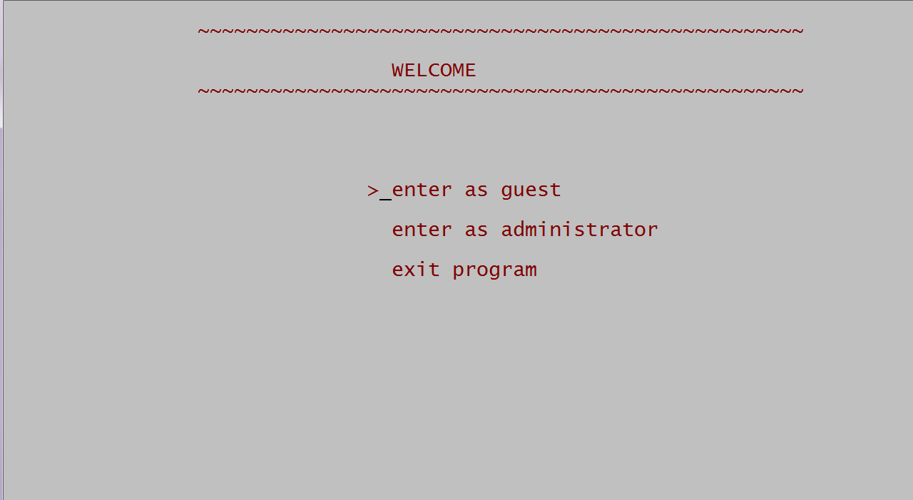

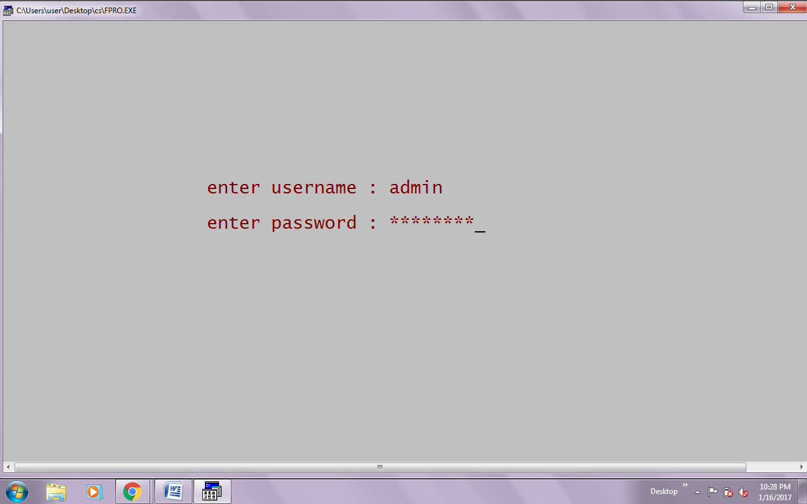

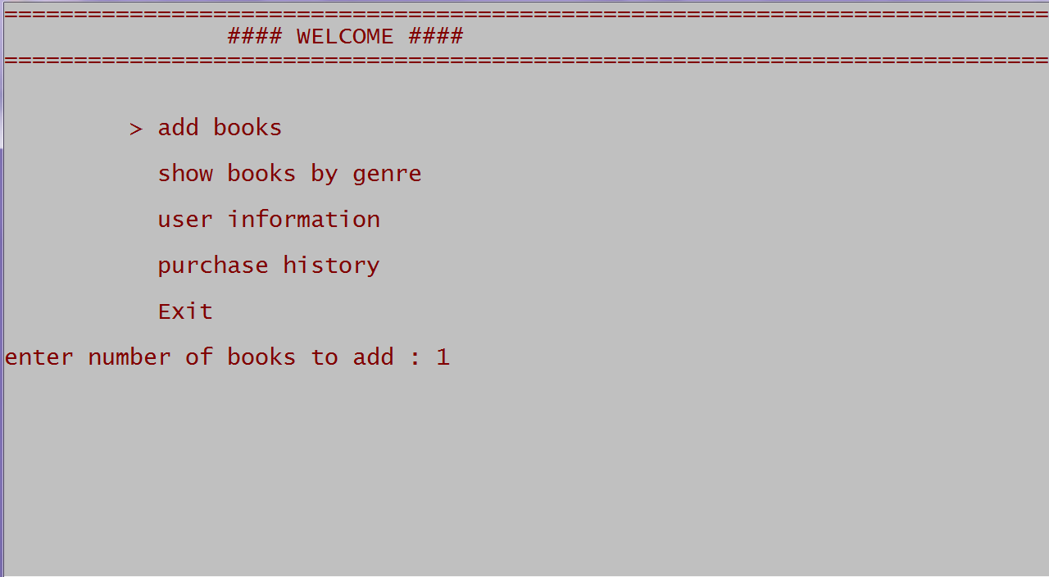

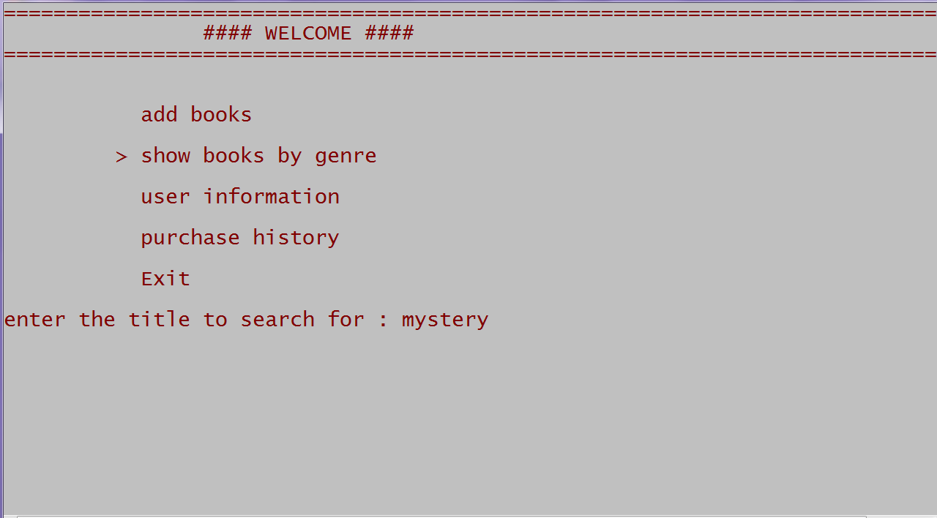

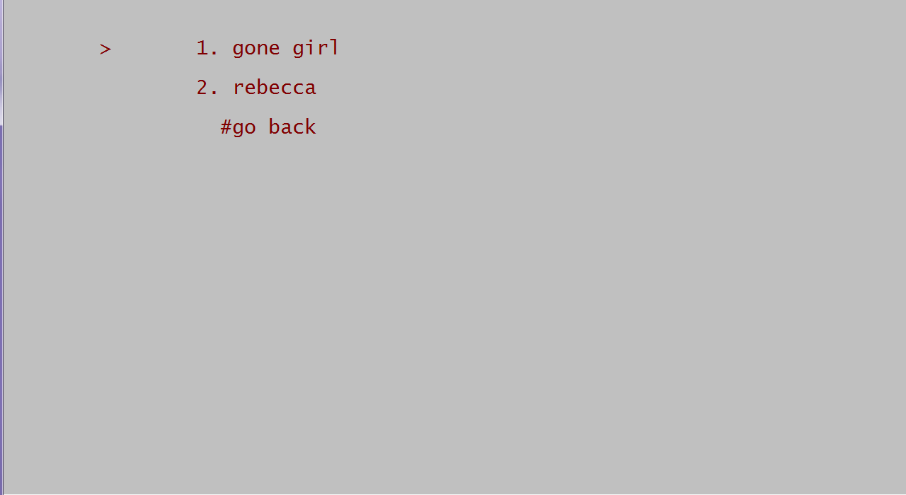

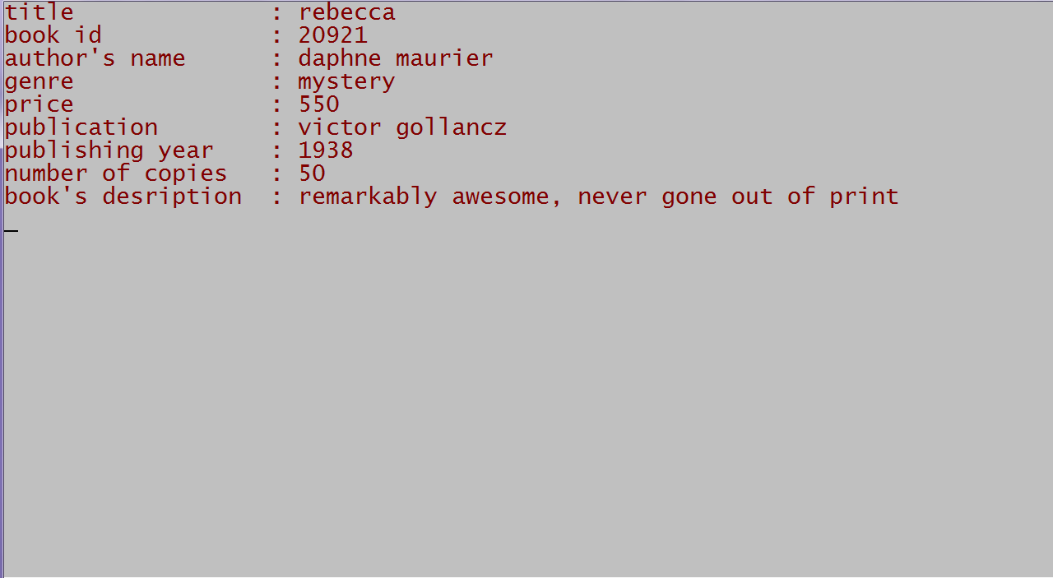

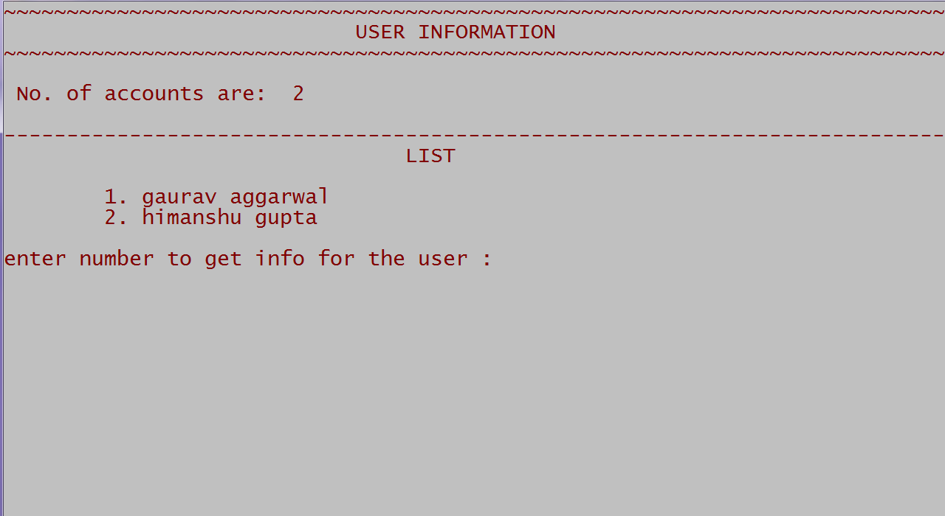

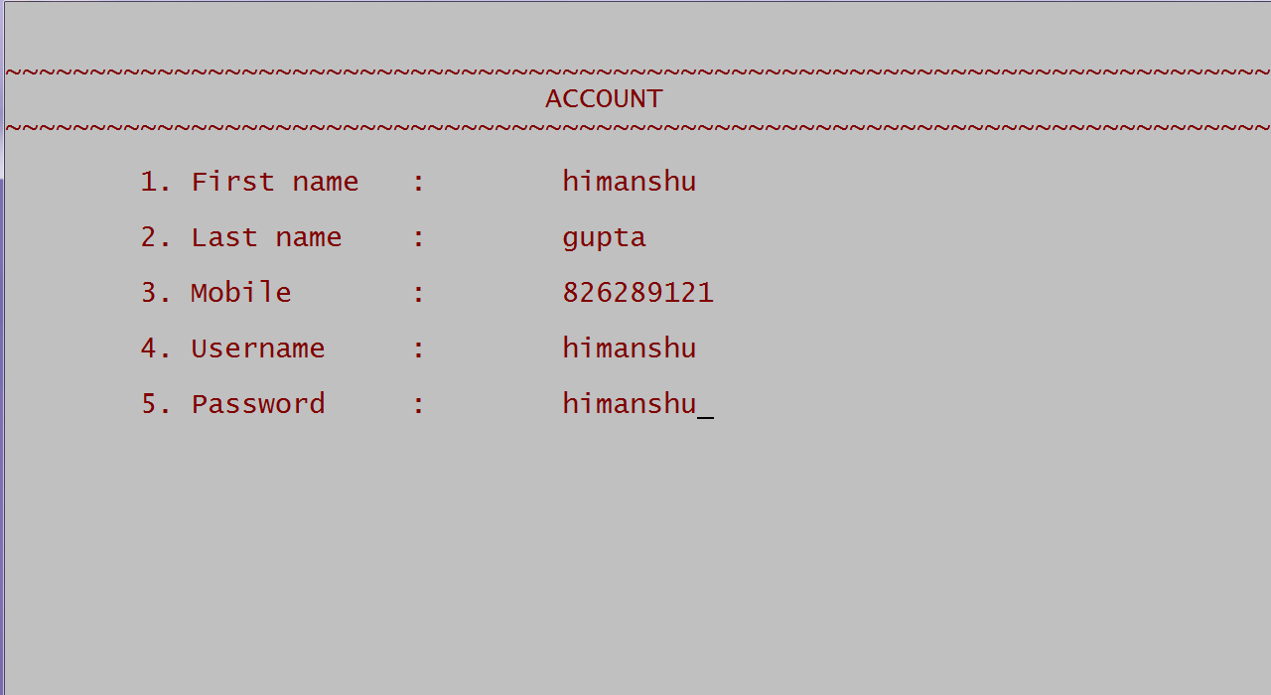

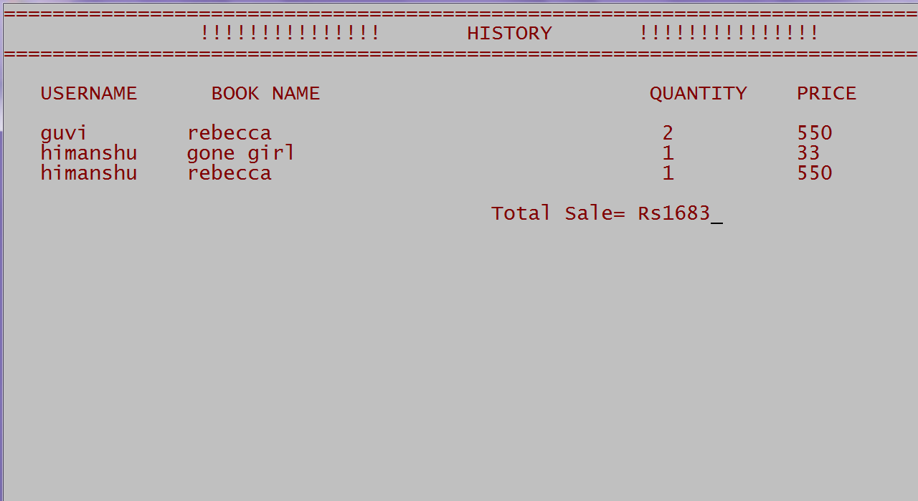

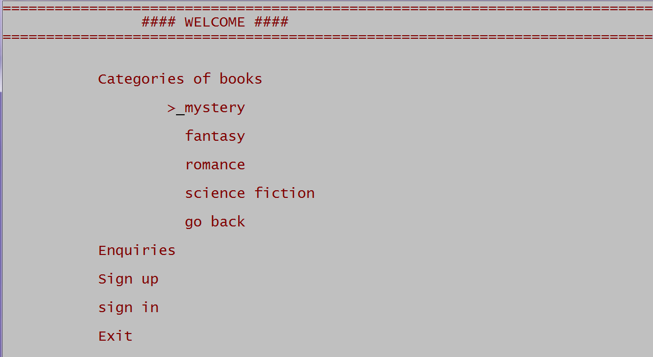

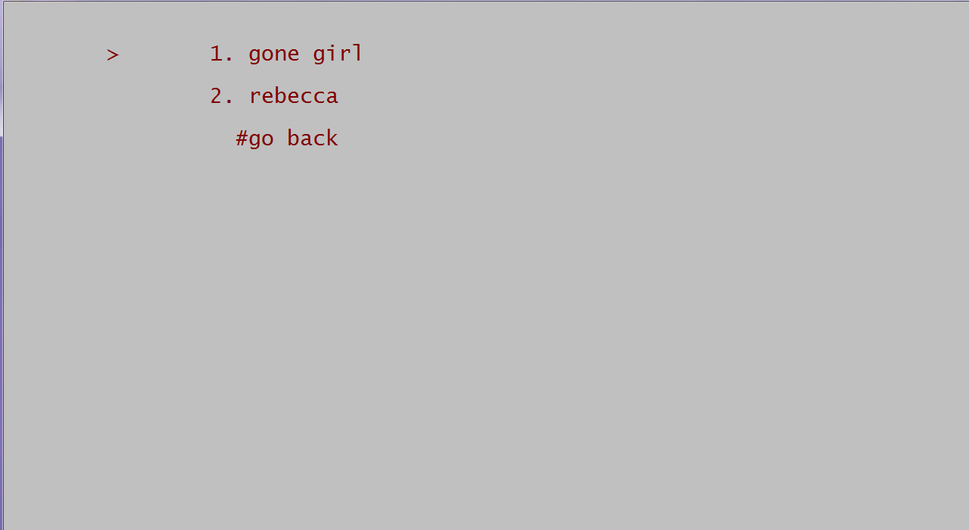

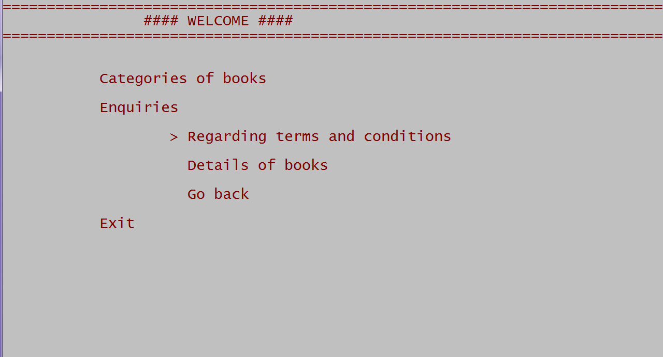

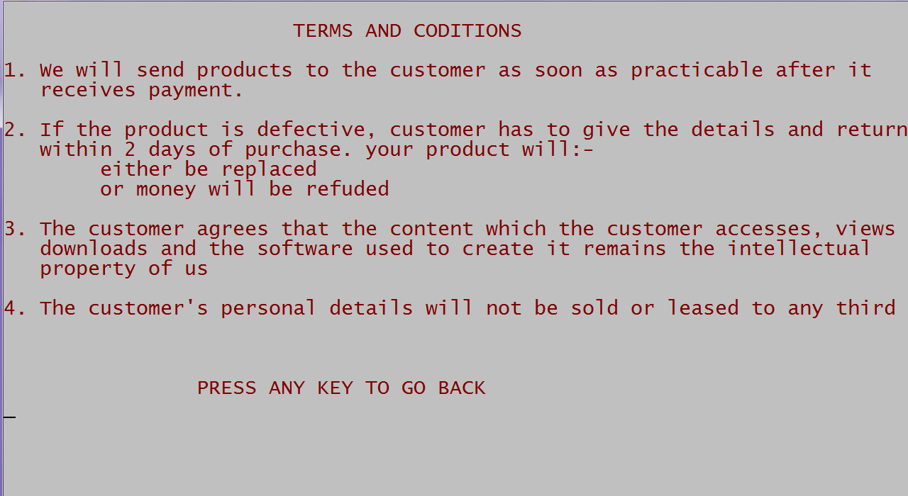

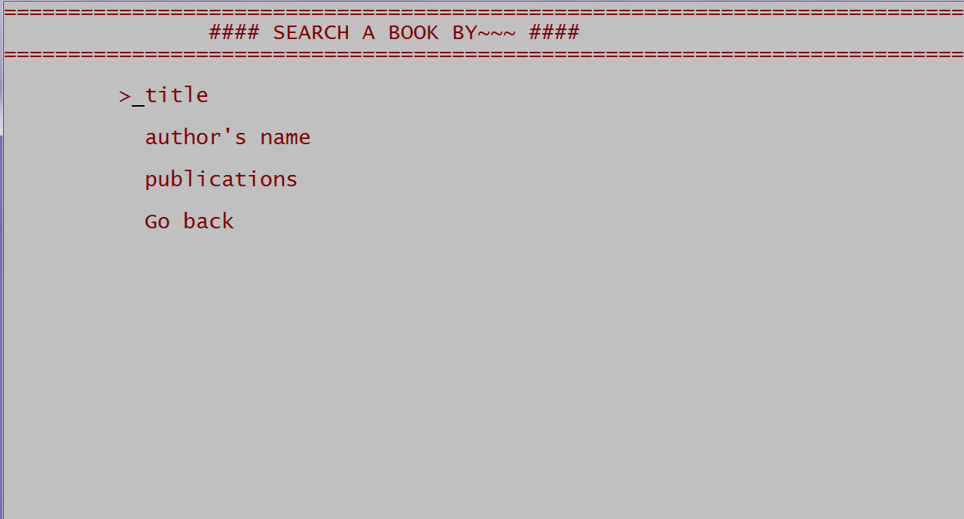

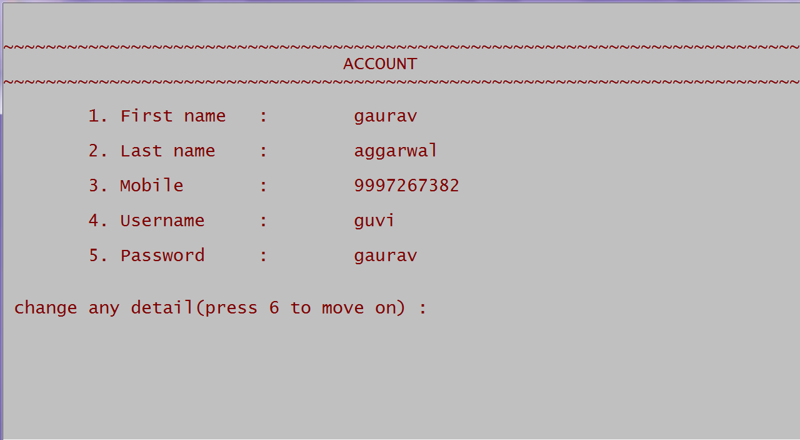

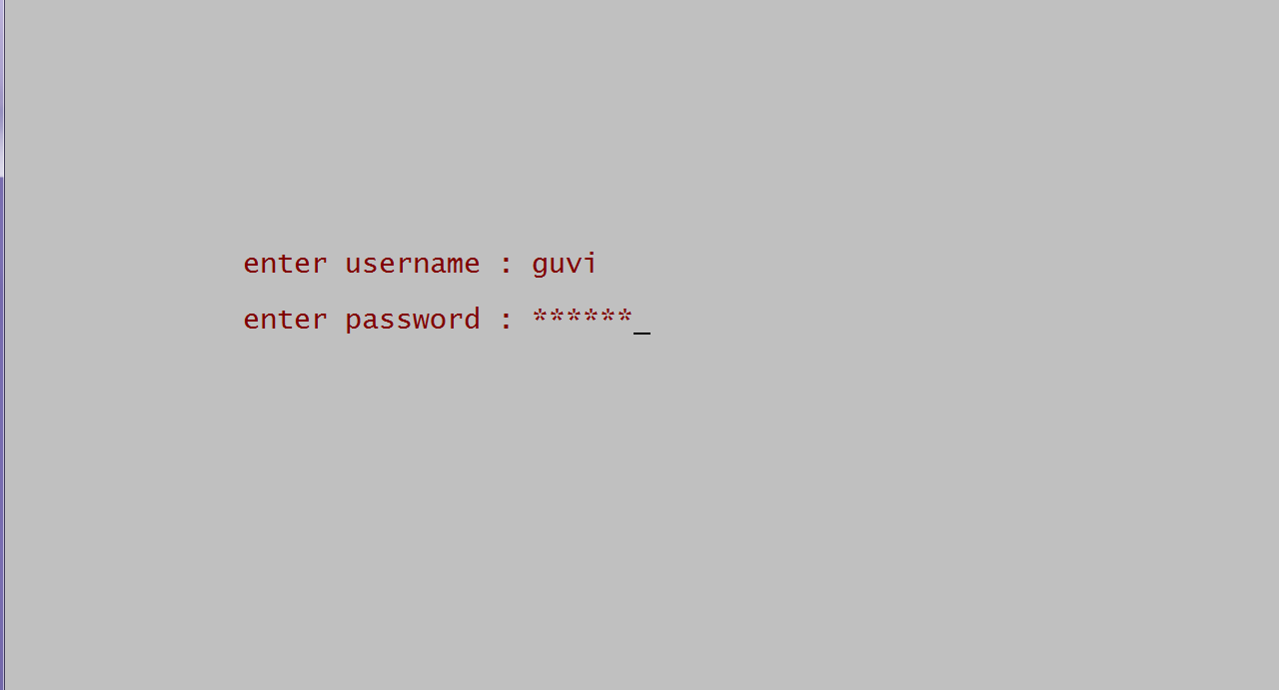

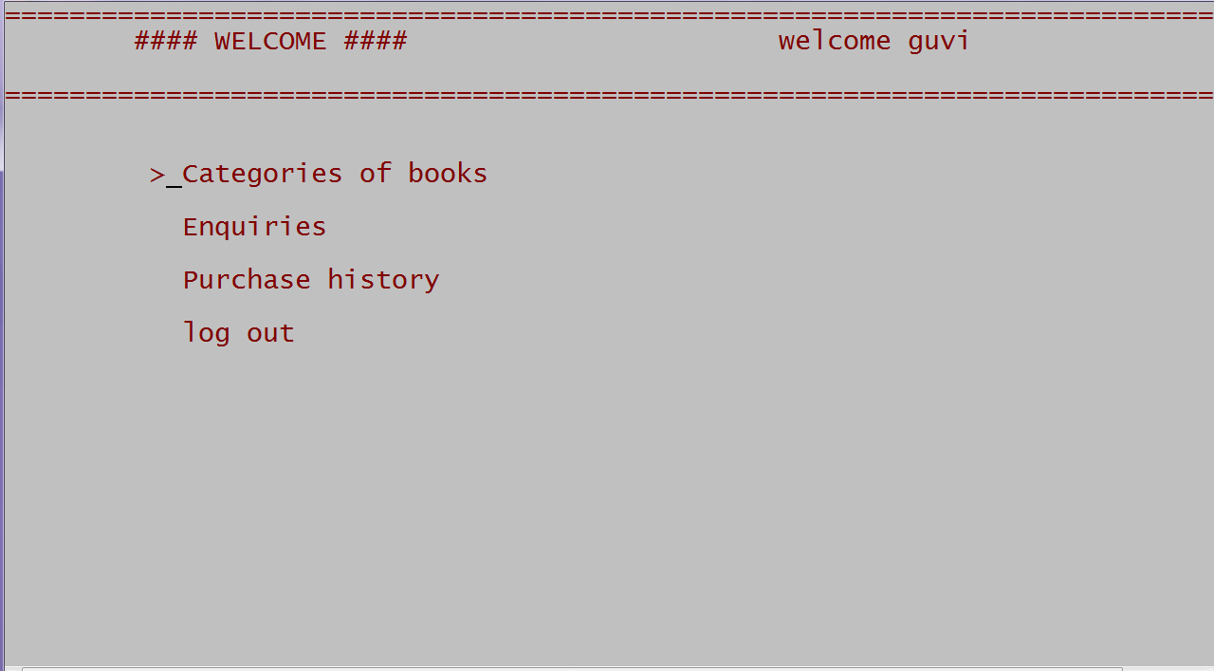

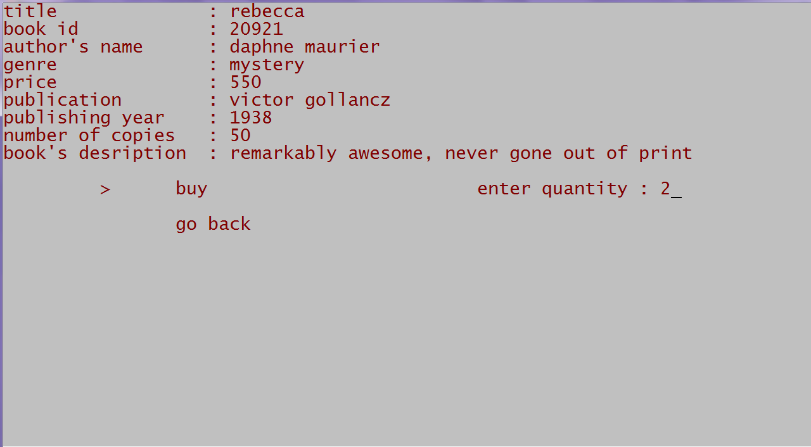

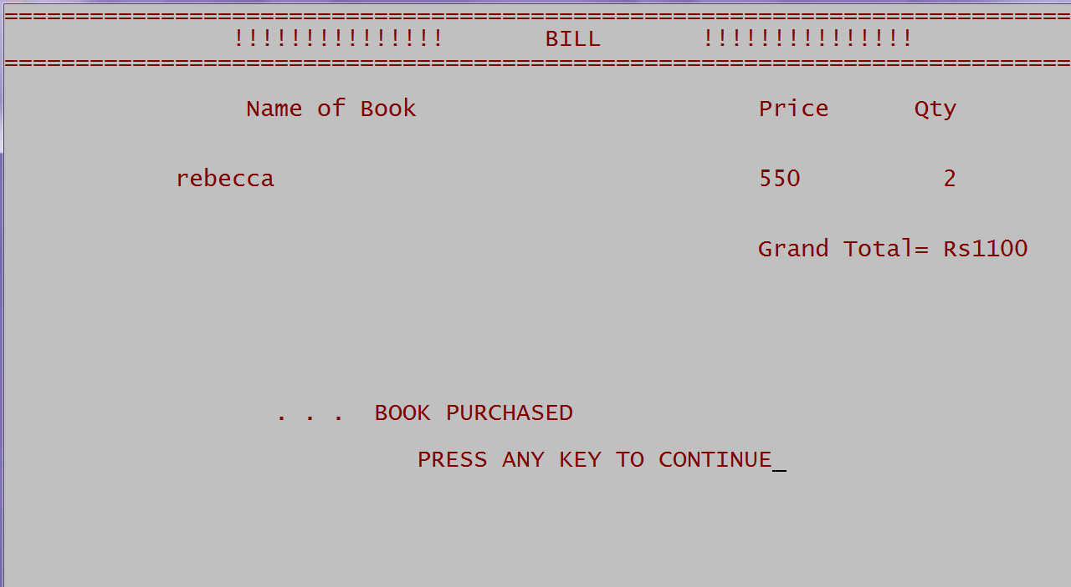

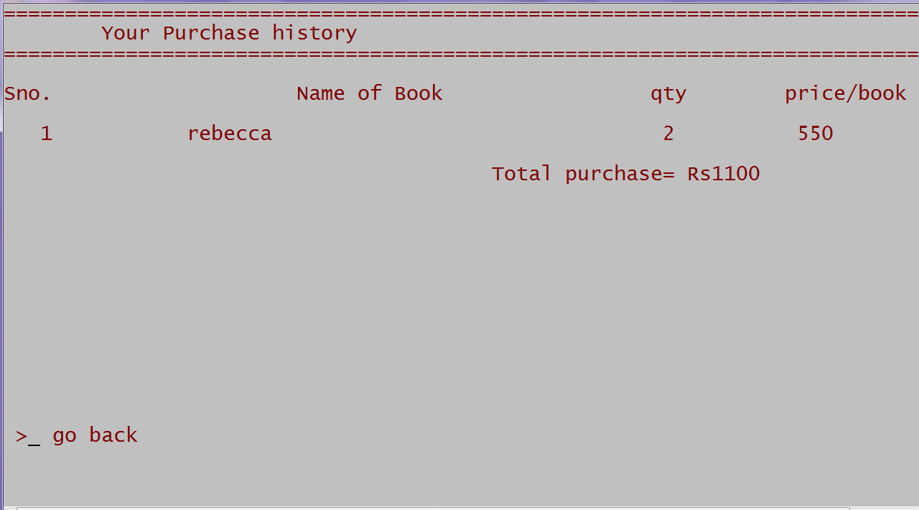



Acknowledgement

I would like to express my special thanks of gratitude to my teacher “Mrs. Shalini ma’am” who gave us this golden opportunity for making this wonderful project “e-book store” which helped me in doing a lot of research and I come to know about so many things. I am really thankful to my teacher. Her excellent and stimulating guidance throughout the course of study for the preparation of my project has helped me a lot. She also helped me to coordinate my project especially in writing this project report and contributed in stimulating suggestions and encouragement.

Secondly I would like to thank my parents and friends who helped me a lot in finalizing this project within the limited time frame. This journey would not have been possible without the support of my teacher, family and friends.

Reference

- Class notes
- Sumita Arora
- TCS
Merits
This project cases up the purchasing of books online. In traditional purchasing of books, it is difficult to keep record of available books for selling books to a customer. So our purpose is to make this buying and selling process more convenient through our program. It makes the work of buyer (customer), seller (admin) easier by keeping record of available books of different types and authors and provides details in a quick manner. It also provides facility to the user for maintaining and managing stock of books. The admin can view the dispatch details of various order booked by various users.
Thus, the project speeds up working of purchasing of books by its efficient way of reserving books and keeping track of various necessary book records online.

LIMITATIONS
The project needs some upgradation:-
- Program should also contain the process of deletion of record or account.
- Program should accept the date when customer buys a book,
- Thus on an overall view the program can be made more advanced.

FURTHER ADDITIONS
- Shopping Cart which allows user to select multiple items in a single go and buy them.
- Track record system which will track the delivery of books to the customers.
- Advanced Design and UI support

